Mark 5:21-23; 5:35-43
Day 1 Get Back in the Boat!
Read Mark 5:21 and Pray.
Jesus had “again” crossed over to the other side.
One crowd rejected him and told him to leave, while a large crowd was waiting for him to return.
Rejection doesn’t mean defeat. Returning doesn’t mean failure. Ministry doesn’t stop because people rejected you or misunderstood your mission. Jesus did not argue of justify. He got back in the boat and sailed to the next miracle.
Describe a situation where rejection and being misunderstood stopped you or left you with a voice ready for explaining and justifying.

Who/What is waiting for your return?

Day 2 Jarius
Read Mark 5:22-24 and Luke 8:41-42; 49-50 and Pray.
Who is Jarius?
Jairus was the father of a 12-year-old girl. He was a ruler in the synagogue of Capernaum therefore he was a well-known religious leader.
The religious leaders during Jesus' time were a diverse group, each with their own beliefs, practices, and agendas. The Pharisees emphasized strict adherence to the law and oral traditions, while the Sadducees focused on the written Torah and held significant political power. The Essenes lived in ascetic communities, awaiting the coming of the Messiah, and the Zealots sought to overthrow Roman rule through armed rebellion. The Sanhedrin, scribes, teachers of the law, and high priests all played crucial roles in the religious and political life of the Jewish people.
Understanding these groups provides valuable insight into the context of Jesus' ministry and the various challenges he faced. Jesus' teachings often challenged the established religious norms and called for a deeper, more authentic relationship with God, centered on love, justice, and mercy. This message resonated with many but also threatened the authority and stability of the religious leaders, ultimately leading to his crucifixion. Through his life, death, and resurrection, Jesus revealed the true nature of God's kingdom and invited all people to partake in its transformative power.
According to the New Testament accounts, many religious leaders of Jesus' time were skeptical of him, opposed him, or saw him as a threat, although not all religious leaders rejected him.
Who were the religious leaders during Jesus' time?
Name a time when you rejected the “norm” for the health, well being and life of your child.

How has the combination of religion and politics hurt the family?

Some gospel writers say my child is going to die, and others say she has died. The Father believed that id Jesus touched her in what every state she is in she would be healed. So, he pleaded, beseeched, worshipped, begged, knelt etc.

Save my child(ren) from physical and spiritual death.

Write a pleading, beseeching, begging, kneeling prayer to God to heal and save our children!

Day 3 It’s Not Too Late!
Read Mark 5:35-37; Matthew 8:23-26 and Pray.
It’s never too late for Jesus! “Do not be afraid, only believe!
Who is in your ear telling you to stop, quit, turn around, it’s over, and don’t bother Jesus? In our finite mind it look like its over, but in God’s infinite mind and power it’s never over until he says it is finished.

List what you still need to “only believe” and not fear!

Day 4 All Y’all Can’t Come!
Read Mark 5:35-37 and Pray.
Why did Jesus exclude some from coming?

Why was only Peter, James and John allowed?

Who in your spiritual circle needs to be included and excluded? When and Why?

Day 5 Get Out!
Read Mark 5:37-43 and Pray.
Jesus came into the house and called it tumultuous meaning great noise, confusion, disorder, or intense agitated emotions. Why are you making all this fuss? What you are doing is not necessary because she is not dead.

Where do you see in your surroundings (Home, work, community) tumult and fussing?

Where is the noise coming from?

Now see the situation through Jesus eyes. What was needed was for the noise, disorder and confusion to leave the house.

What was the crowd’s response to being told to leave because she was not dead?

I’m doing my job!
What does it mean when you are paid to be noisy? Payment does not always mean money.

What happened when Jesus spoke to Jarius’ daughter?

What were Jesus’ instructions to mom and dad and why?

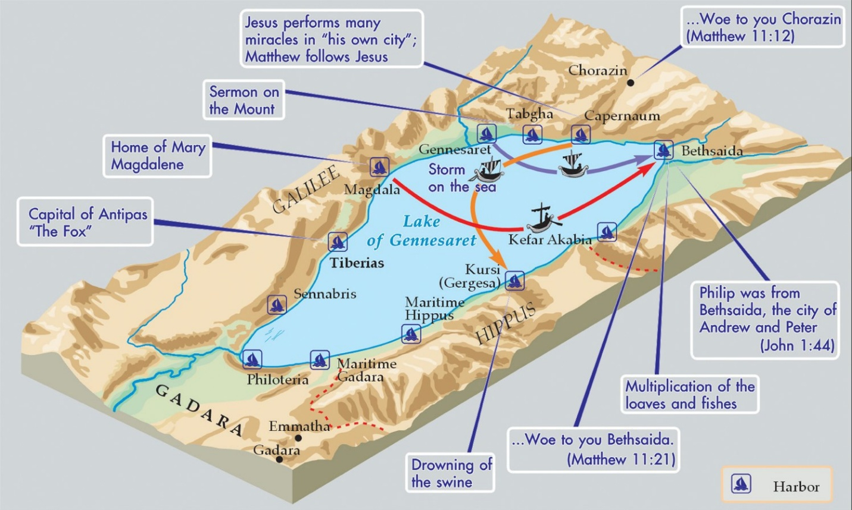

Why Many Religious Leaders Opposed Jesus
- He challenged their authority. Jesus often criticized some Pharisees and other religious leaders for hypocrisy, legalism, and focusing on outward religious practices rather than genuine faith and compassion.
- He interpreted the Law differently. Some leaders believed Jesus was disregarding traditional interpretations of Jewish law, especially concerning the Sabbath and religious customs.
- He attracted large crowds. His growing popularity concerned some leaders who feared losing influence or provoking unrest.
- He made claims that many considered blasphemous. Jesus' teachings about his relationship with God led some religious authorities to view him as a false teacher or blasphemer.
Religious leaders who supported or respected Jesus
Not all religious leaders were hostile toward him:
- Nicodemus, a Pharisee, met with Jesus and later spoke in his defense.
- Joseph of Arimathea, a member of the Jewish council, was described as a follower or sympathizer of Jesus.
- Some priests and religious leaders are described in the New Testament as eventually believing in him.
In summary
Many religious leaders viewed Jesus as a challenge to their teachings, authority, and understanding of God's law, leading to significant conflict. However, a number of religious leaders were curious about him, respected him, or became his followers.

Jewish Mourning Customs in the Time of Jesus
In the first-century Jewish world, mourning was both a family and community act, deeply rooted in religious law and cultural tradition. The accounts of Lazarus’ death and Jesus’ resurrection (John 11) reflect these customs in several ways.
Immediate Burial and Communal Presence
Jewish law required burial on the same day of death, before sundown, due to the warm climate, purity laws, and respect for the dead Bible Hub. This meant mourning began immediately after interment. In Bethany, where Lazarus was buried, many Jews gathered to console the family, reflecting the halakhic duty of nichum aveilim — comforting the bereaved Bible Hub. This was a public, communal act, not just a private family affair.
Stages of Mourning
Traditional mourning had defined periods Bible Hub:
- Aninut – from death until burial, with no Torah study or work.
- Shiva – seven days of intense mourning at home, with visitors offering presence, prayer, and a “meal of consolation” (bread, eggs, lentils).
- Sheloshim – thirty days of lighter restrictions, such as no shaving or celebrations.
Rituals and Expressions of Grief
Mourning included lamentation, weeping, and tearing of garments (keriah), especially for close relatives Bible Hub. Loud wailing was customary, sometimes aided by professional mourners. The Bible records Martha and Mary’s lament (John 11:20–33) and Jesus’ own weeping (John 11:35), both in line with these traditions.
Burial Practices
The body was washed, anointed with spices and oils, and wrapped in linen Bible Hub+1. Spices honored the deceased and reduced odor. Lazarus was buried in a cave tomb with a stone sealed over the entrance, typical of wealthy Jewish families Bible Hub+1.
Social and Religious Significance
Mourning was a communal support system — friends, neighbors, and community members gathered to share the burden of grief pastors.ai+1. The presence of many mourners in Bethany four days later shows that the shiva period was still ongoing, and that communal solidarity was a core cultural value.
Special Cultural Context in the Lazarus Narrative
Jewish belief held that the soul remained near the body for three days; after that, decomposition began, making resurrection unlikely pastors.ai. Jesus’ delay in visiting until after the fourth day was culturally significant, underscoring the finality of death and the miraculous nature of the resurrection.
In summary: Jewish mourning in Jesus’ day combined immediate burial, structured mourning periods, communal consolation, and public lamentation. These customs shaped the emotional and social backdrop of events like Lazarus’ death, making the resurrection both a cultural and theological turning point.

