Mark 4:30 – 4:34
DAY 1 The Parable of the Mustard Seed
Read Mark 4: 30 -34 and Pray.
Grow Deeper!
Roots grow in darkness, away from the light, pushed down by gravity to move deeper into the soil.

What does it mean to you to grow deeper before you grow up?

Water and nutrients are found in the soil. The roots grow deeper into the soil gathering all that is needed to sustain life above the ground.

What is sustaining your roots below the ground?

The root system is more extensive underground than it is above ground.
Describe how you are making room for your roots to grow deeper and wider.

DAY 2 The Parable of the Mustard Seed
Read Mark 4: 30 -34 and Pray.
Growing Upward
Above the grown the tree grows towards the light. The tree becomes shelter, shade, fruit, protection, nests and more. Its purpose is to benefit many including those who fly, walk, and crawl. It benefits man and animal.

List how your tree (your faith) has become a ministry for others to find shelter, shade, food, protections and more.

DAY 3 The Parable of the Mustard Seed
Read Mark 4: 30 -34 and Pray.
Christianity started very small and it will continue to grow into a worldwide community of believers. There are faithful followers in every part of the world, on every continent.

Your faith no matter how small can-do great things.

What does God want you to grow from the mustard seed faith he has given you?

What steps will you take to grow your faith?

What actions will you take to grow the community of believers at home, work, in the community ND t church?

DAY 4 The Parable of the Mustard Seed
Read Mark 4: 30 -34 and Pray.

Mustard Seed | Kingdom of God | Faith Growth
Starts tiny | Begins with few believers | Initiates with small faith acts
Grows into a large tree | Expands across the globe | Develops into profound spirituality
Provides shelter | Offers hope and salvation | Leads to transformative changes
Action Items: Make a plan on how you will engage, practice, participate, learn and advocate.
- Engage in daily reflection and prayer to nurture a deeper spiritual connection.
- Practicing gratitude even in small matters helps reinforce positive thinking.
- Participate in community service, which fosters a sense of collective faith and responsibility.
- Seek continuous learning through scriptures and faith-based literature.
- Adopt and advocate for justice and ethical practices in your daily life.
DAY 5 The Parable of the Mustard Seed
Read Mark 4: 30 -34 and Pray.

There is a storm coming! Prepare for the storm with a prayer of praise and thanksgiving.

Write a prayer to God about the following:
Praise Him for his provisions before the storm.

Thank Him for the protection during the storm.

Thank Him in advance for yielding into the storm but not breaking before, during or after the storm.

Thank Him for the storm, acknowledging He is bigger than any storm that is coming your way.
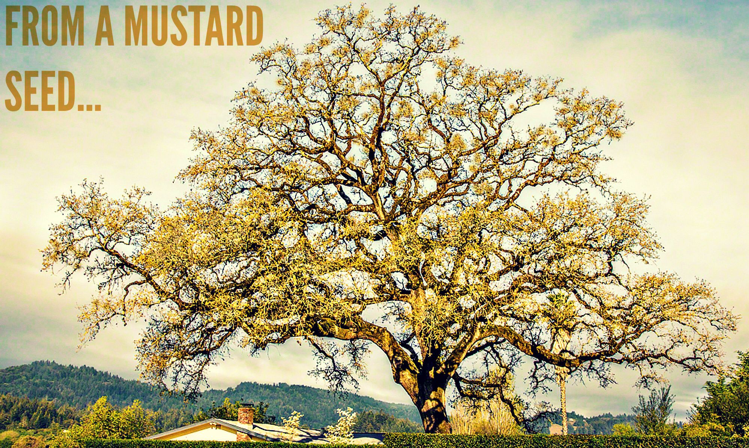
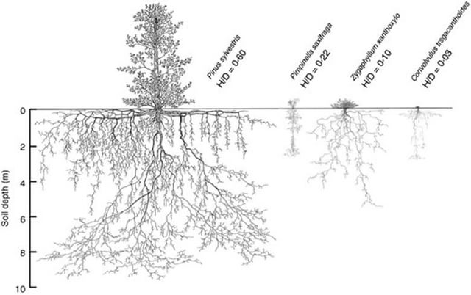

Botanical Context
In the context of the New Testament, the mustard seed generally refers to species like black mustard (Brassica nigra), white mustard (Sinapis alba), or brown mustard (Brassica juncea). These were the small-seeded, fast-growing herbs prevalent in 1st-century Palestine. The plants are annuals, meaning they complete their life cycle—from seed to flowering—within a single growing season. Seeds were 1–3 mm in diameter, making them very small, yet capable of producing plants exceeding 3–3.5 meters (10–12 ft) under optimal conditions

Soil Conditions
- Mustard thrived in fertile, well-draining loamy soils commonly found in the Galilee plains and the Sharon region.
- These soils were often irrigated naturally by seasonal rains or supplemented by small-scale channels or cisterns.
- Mustard seeds germinate easily without significant cultivation; in fact, fields often contained self-sown plants alongside deliberately cultivated ones

Climate and Seasonal Factors
- The Mediterranean climate of ancient Palestine—mild, wet winters and hot, dry summers—was ideal for mustard growth.
- Sowing typically occurred in the autumn, allowing seedlings to establish during winter rains. Growth accelerated by spring, reaching full size in approximately 2–3 months (55–70 days)
Cultivation Practices
- Mustard required minimal human intervention; seeds sown directly into the soil germinated rapidly.
- Farmers sometimes intercropped mustard with other vegetables or used it as a cover crop for weed suppression and soil enrichment due to its rapid biomass accumulation.
- The plants’ non-woody, soft stems allowed rapid vertical growth but could not tolerate prolonged drought without irrigation

Plant Characteristics Relevant to Biblical Imagery
- Mustard’s fast growth from tiny seed to substantial shrub-like plant made it symbolically powerful. It could appear “tree-like” in height, though botanically it remained herbaceous
- The dramatic size difference between seed and mature plant—from ~2 mm to over 3 meters tall—served as an effective metaphor for growth, whether spiritual (Kingdom of God) or practical (field productivity)

Summary of Growing Requirements in Biblical Palestine
Factor | Requirement / Observation
Soil | Fertile, well-draining loam
Climate | Mild Mediterranean, winter rains, spring warmth
Sowing Season | Autumn or early winter
Growth Duration | 55–70 days to full height
Plant Type | Annual herb, rapid vertical growth
Seed Size | 1–3 mm diameter
Height at Maturity | 1–3.5 meters (3–12 ft.)
Maintenance | Minimal; natural germination common

Conclusion
Biblical mustard seeds germinated easily in naturally fertile fields of first-century Palestine, requiring little cultivation. Fast growth under Mediterranean climatic conditions allowed seed-to-plant transformation within a few month, creating shrubs tall enough to inspire metaphors of shelter and growth in Jesus’ parables. This combination of small seed, rapid germination, and large mature plant made mustard a salient illustrative plant for audiences familiar with agricultural practices of the region.

References
Bible Hub, Topical Bible: Mustard, Alibaba, Scienceinsights.org

