INTRODUCTION TO MARK

The Gospel of Mark will be a yearlong Bible Study. This study is designed for you to spend time in the Word daily. It is designed for you to read it, study it, ponder it, let it settle in, examine it, walk in it, breathe with it, apply it personally and grow with it.
Spend time in prayer each day asking God to reveal His heart to you, to show Himself through daily reading. Ask the Holy Spirit to settle into all your empty spaces and dark places bringing his light, his understanding and his love.
Throughout the year you will have a weekly study lesson. For 5 days of that week, you will have a few scriptures to read, questions to answer and thought-provoking things to ponder and pray about. We will meet once a week at Bible Study to discuss the lesson for the week. You are encouraged to journal and write down your thoughts and questions.
Each week you will receive a new lesson and begin the 5-day process again. We will continue until we have completed all 16 chapters of Mark.

Purpose: To present the person, work and teachings of Jesus Christ. Mark will teach us how to listen to the voice of Jesus!
Author: The author of the Gospel of Mark is John Mark (Latin – Mark and Hebrew – John). John Mark was not one of the 12 disciples. It is believed that he is recording Peter’s eyewitness accounts of Jesus. He is known for his relationship with Peter whom he served faithfully until his death. John Mark accompanied Paul and Barnabas of missionary journeys. His father’s name was Aerotropolis, and his mother’s name was Mary. He was also a cousin to` Barnabas. He is from the tribe of Levi. John Mark grew up in Africa and died in Alexandria on the coast of the Nile. Alexandria was an intellectual center of Africa and believed to be the first Christian school.
Audience: John Mark wrote to the gentile Roman followers of Jesus.
Literary Style: This gospel is fast moving. You will experience immediate transitions between ministry events.
Date Written: Between A.D. 55 and 65. Possibly the first Gospel written.
Key Verse: “For even the Son of man came not to be ministered unto, but to minister, and give his life a ransom for many.” Mark 10:45

Key Themes:
- Jesus was Savior and a Servant.
- Jesus willingly and purposefully sacrifices his life for humanity’s broken relationship with God.
- Jesus demonstrated his power through performing miracles.
- Jesus taught about God’s kingdom.

The Gospel of Mark starts with John the Baptist baptizing Jesus and does not mention the story of Jesus’ birth. It has been 400 years between the Prophet Malachi (Last book of the Old Testament) speaking to God’s people and John the Baptist preaching in the wilderness.
The 400 years of silence is called the intertestamental period. It is considered the divine and intense preparation for Jesus’ earthly ministry.
There were three major developments during this period.
- Greek became the dominant language of the Mediterranean which allowed for the gospel to be widely written and understood. This created a universal language for the early church to use in writing and teaching.
- The Roman empire had a vast network of roads, trade routes, and postal systems making travel and communication much easier.
- The Jewish people had dispersed through the Mediterranean establishing synagogues in foreign cities creating spaces for early Christian ministries. There is a shift from Jewish history to a global landscape for the New Testament era.
Many theologians interpret the silent years as a consequence for Israel’s disobedience, unfaithfulness and idolatry.
For generations there has not been a word from a prophet. However, was God truly silent?
Was God not active?
Was He not speaking?
Was He not performing miracles?
Was He not answering prayers?

God is always active, answering prayers, performing miracles, preparing the way. He knows what you need, He is present in your life. He is active in your life!

Why does God seem silent in your life?

What are His divine preparation for your life during the silent years?

In our immediate culture we want God to speak, answer and deliver today.

How long are you willing to wait for God to speak his truths and to prepare your way forward?

Read Malachi 3:1 and Isaiah 40:3 and Pray.
John’s mission was to announce Jesus Coming! Roman Christians were more interested is Jesus’ arrival in their town and were less interested in the story of Jesus’ birth. The people were ready for Jesus. They flocked to the wilderness to hear a wilderness preacher.

Describe how eager you are when it comes to hearing a personal word from God?

Give an example when Jesus was speaking and you were or were not listening.

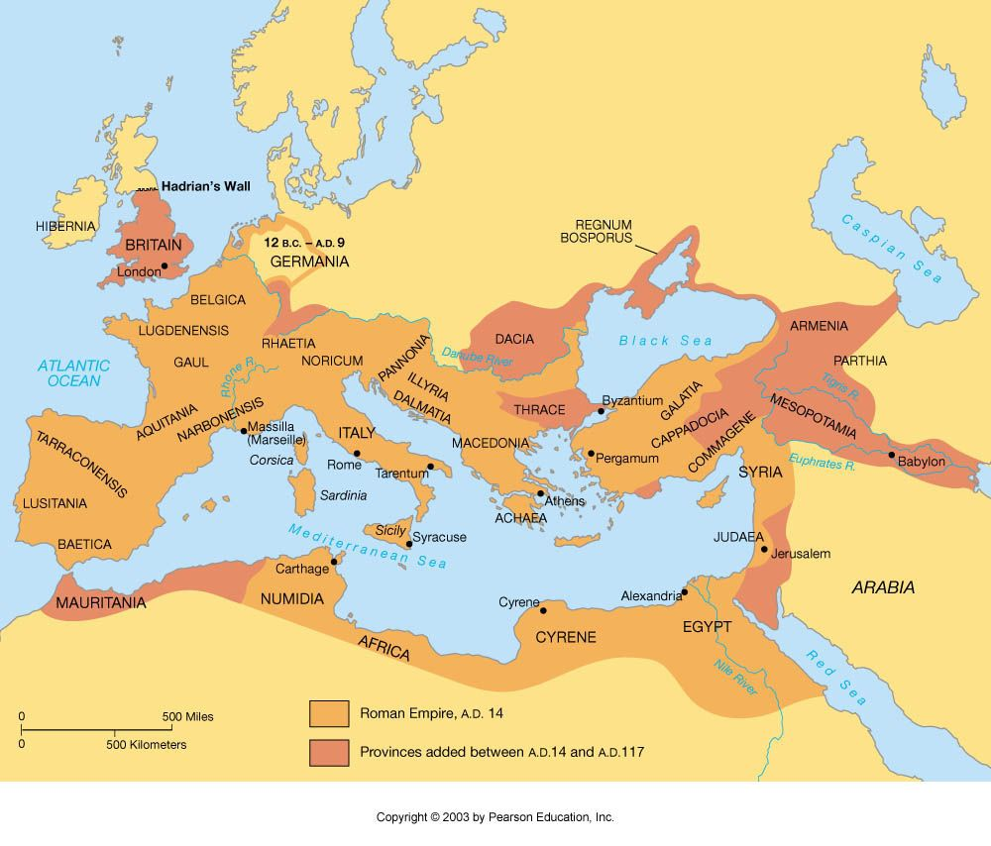

JOHN THE BAPTIST

Birth and Early Life:
- Luke 1:13-17 John the Baptist's birth was foretold by the angel Gabriel to his father, Zechariah, a priest, and his mother, Elizabeth, who was a relative of Mary, the mother of Jesus.
- He is never to take wine or strong drink, and he will be filled with the Holy Spirit even from his mother’s womb.
Ministry:
- John's ministry began in the wilderness of Judea, where he preached a message of repentance and the imminent arrival of the Kingdom of Heaven. Matthew 3:1-2 states, "In those days John the Baptist came, preaching in the wilderness of Judea and saying, 'Repent, for the kingdom of heaven is near.'" His call to repentance was accompanied by the act of baptism, symbolizing the cleansing of sins and preparation for the coming Messiah.
- John's appearance and lifestyle were reminiscent of the Old Testament prophets, particularly Elijah. He wore clothing made of camel's hair and a leather belt, and his diet consisted of locusts (fruit or pods from the locust tree) and wild honey (Matthew 3:4). This austere lifestyle underscored his message of repentance and his role as a prophet.
- One of the most significant events in John's ministry was the baptism of Jesus. Despite his initial reluctance, John baptized Jesus in the Jordan River, marking the beginning of Jesus' public ministry. Matthew 3:13-17
Imprisonment and Death:
- John's boldness in speaking truth to power led to his imprisonment by Herod Antipas. John had publicly condemned Herod's unlawful marriage to Herodias, his brother's wife. This confrontation ultimately led to John's execution.
- John's boldness in speaking truth to power led to his imprisonment by Herod Antipas. John had publicly condemned Herod's unlawful marriage to Herodias, his brother's wife. This confrontation ultimately led to John's execution.
Legacy:
- Integrity: He linked belief with behavior, insisting that justice, generosity, and self-control are non-negotiable. In personal and professional life, that means being the same person in private as in public.
- Humility: Despite his popularity, he refused the role of celebrity. He knew his limits and kept the focus on what mattered most.
- Courage: He told the truth to power without hate or self-righteousness.
- Call to repentance!

Topical Bible: John the Baptist


Honey Locust Tree Fruit.

